STRENGTHENING ARAB ECONOMIC INTEGRATION FOR SUSTAINABLE DEVELOPMENT

LAUNCH OF THE PROJECT IMPLEMENTATION IN EGYPT CUSTOMS AUTHORITIES

NATIONAL SEMINAR FOR SENIOR MANAGEMENT OF EGYPTIAN CUSTOMS AUTHORITIES AND AGENCIES IN CHARGE OF EGYPT NATIONAL SINGLE WINDOW

Draft Concept Note and Provisional Annotated Agenda

(Cairo, Egypt, January 22nd and 23rd 2019)

Background
Egyptian economic growth has improved in recent years and shows more potential for better performance within the national programme of reform and modernization. According to the Global Competitiveness Index of 2018, Egypt is still required to make substantial efforts to improve competitiveness to sustain the growth toward achievement of Sustainable Development Goals in coming years.
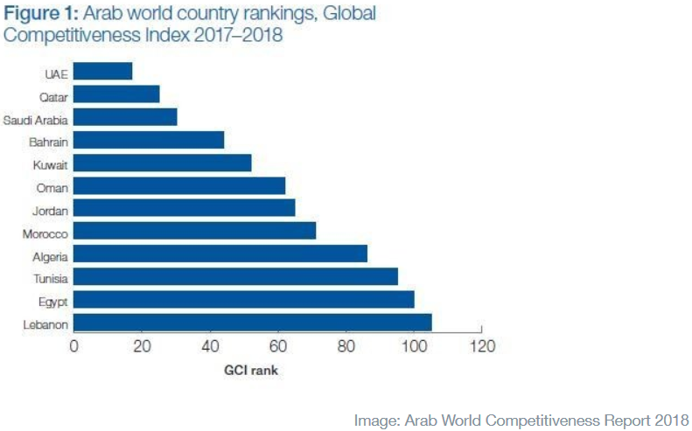
The Global Competitive Report of 2018 also specifies a strong correlation between competitiveness and income level of all countries. In order to achieve better livelihood and more business opportunities in the country, the business environment needs to be made more viable. Adoption of a National Single Window by a country would promise substantial improvement in providing better public services, more efficiency and convenience for consumers, businesses and industries.

In order to improve national competitiveness, more efforts are required by the regulatory agencies as well as by the private sector in various capacities. For that, optimizing regulatory controls with less costs and more convenience to the public and end-users is essential. Furthermore, leveraging on advantages of information and communication technology can be seen as a new asset to policy instruments that the Government of Egypt has in operationalizing modernized control. A National Single Window, essentially is a platform, designed for this purpose.
The project of Strengthening Arab Economic Integration for Sustainable Development (AEISD), by UNDP, aims at provision of support to Arab countries to improve the regional connectivity and trade efficiency as continuation to positive effects of the earlier programme of assistance in 2014 – 2016. UNDP starts its implementation with Egypt Customs Authority (ECA), Ministry of Finance in late December 2018 after having completed the administrative process with concerned Egyptian authorities. A new Work Programme was designed and endorsed by the Commissioner of ECA. One of main components of the programme relates to the design and development of Egypt National Single Window (ENSW).
The ECA informed the new decision by the Government of Egypt of assigning ECA as the lead agency in the ENSW. In 2015, UNDP assisted Egypt with the preparation of the ENSW Roadmap and the recommended framework of institutional arrangements for ENSW was positively considered by EgyTrade. Support to the latter continued until Quarter IV of 2016.
Having a NSW operational aims to facilitate secured international trade, improve regulatory control and to collect due revenues under the national laws. These can be seen as the basis in putting the SAFE framework into action with participation of regulatory authorities and the private sector. Indeed, the NSW constitutes the digitalized platform of data and information as well as its processing for expeditious release of shipments through international entries to the customs jurisdictions. For certain, it would assist better management by the Government with more accurate and timely data in real time. It is well proven that adoption of a single submission, carrying out coordinated information, and o unified application of relevant laws and regulations, create a suitable environment for investment, business, trade and industry.

- Purpose of the Seminar on ENSW
The National Seminar on ENSW aims to equip the senior management of ECA with:
- The conceptual approach of a National Single Window and Egypt National Single Window.
- Consultation on the thematic definition of ENSW.
- ENSW and modernization of trade and customs procedures.
- Working with operators of a National Single Window.
- Key concept of the draft ENSW.
A National Single Window is a major reform and modernization assignment with participation from several governmental agencies. In recent years, more and more NSWs are being designed for not only public but also private sector while capitalizing on advantages and technological advances. Specifically, a successful NSW should capitalize on the partnership of various agencies and the collaboration with traders, port operators, shippers, freight forwarders and manufacturers.
A successful implementation of a NSW rests with efforts on reform and modernization of trade- and customs-related procedures on the basis of international standards and practices. Information and Communication Technology would enable these efforts to progress faster.
Specifically, the seminar would also present key features of the draft Roadmap of ENSW for consultation with the senior management, and expectedly it would lead to identify subsequent steps in updating the draft as well as concerned matters. During the seminar, experts would assist the senior management of ECA and concerned agencies with detailed understanding of a National Single Window, including required preparations.

Objectives of the training
The seminar pursues the following targets:
Objective 1: Explaining the NSW concepts. Steps of building the NSW.
Objective 2: Various models of NSWs for different sectors and industries.
Objective 3: Presentation of the draft Roadmap of ENSW. .
Objective 4: Clarifying the cooperation and contribution of the participating agencies in the NSW.
Objective 5: Explaining the crucial role of senior management in building and operating the NSW.

- Expected Outputs of the Seminar:
- Adoption of the definition of Egypt NSW in the operational environment of Egypt through discussions and exchange of views, facilitated by UNDP. Review of international best practices in developing a National Single Window.
- Development of a National Single Window and modernization of trade and customs practices.
- Presentation of experiences of preparatory works for a national single window
- Presentation of experiences of a Customs-oriented Single Window of one Arab country as illustration.
- Discussion of future activities to activate ENSW.

- Technical Documentation
- Recommendation 33 by UNECE.
- Draft 1 of the Roadmap of Egypt NSW.
- Technical paper on the conceptual approach of Egypt NSW by UNDP.

- Work methodology
The workshop would be interactive and conducted in a blend of thematic presentations, short exercises and plenary discussion. The main reference consists of the draft Roadmap of ENSW, the technical paper on the conceptual approach for ENSW and Recommendation 33, as well as the WTO Trade Facilitation Agreement.

- Target audience of the training

- Heads of Departments, Divisions in charge of procedures, risk management, of applications of information and communication technology.
- Representatives of the Ministry of Finance.
- Representatives of GOEIC.
- Representatives of port authorities.
- ECA Senior managers.
Nomination of suitable participants is the responsibility of the ECA.

- Experts/Resource Persons:
- The technical team of UNDP.
- An international expert on NSW
Sharing experiences: Jordan Customs.

